**Using the Debugger**

Debugging is the process of identifying and removing logical and runtime errors from your code.

**Two Different Approaches to Debugging**

1. Print out values of variables and flow of execution to track down issue
2. Use the debugger that comes with your IDE
   1. Debuggers allow you to
      1. Step through the code one statement at a time
      2. Step into or over methods
      3. Set breakpoints - a place where the code will stop executing
      4. Examine variables - watch variables - modify variables
      5. Display the call stack

**Using Debugger in Eclipse**

* Set a breakpoint



* Start the debugger: From Run menu option select **debug**, or click debug icon  and select file you want to debug



* If you get this message click remember my decision and click switch

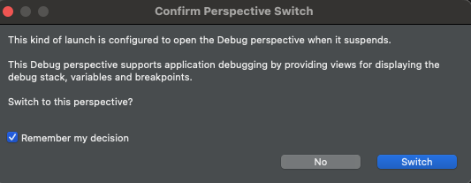

* You will be in the **Debug perspective** where you will see Variables on the right side of Eclipse.

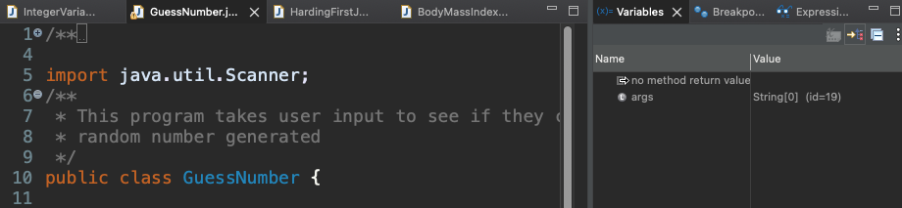

* You can watch variables and step through code. In the window with the code, notice execution is stopped on line with breakpoint. Highlighted line means it **has not been executed yet**

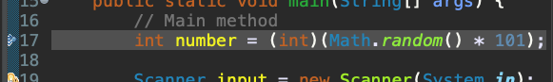

* Now you can “**step**” through code
  + These two arrows in upper menu allow you to **step into** and **step over** code 
  + You **DO NOT** want to “step into” the Scanner
  + You want to "step over" the line: Scanner input = new Scanner(System.***in***);
  + In our case we don't want to debug code from the **java.util** package. If you want, you can set things up so you don't step through code that is imported to make debugging easier for you. Go to Eclipse -> Settings -> Java -> Debug -> Step Filtering



* Now click “step” icon until you get to the line the following line and notice the code is **waiting for you** to enter a value in the console just as if I was running it without the debugger. If you click “step over” again nothing happens.



* Enter a value in the console window. Notice how the code now highlighted is the next executable line of code.

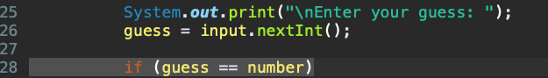

* Notice in **variables window** on right

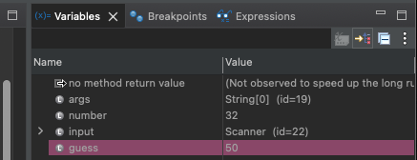

* Check for problems by clicking on the Problems tab. It is ok to use resources to help with fixing errors and warnings. Make sure you include the resource in your submissions. For example, here is how I used chatgpt and notice the questions I asked to understand the information better. <https://chatgpt.com/share/922d4687-104d-4f8b-8841-1e802716b0f2>

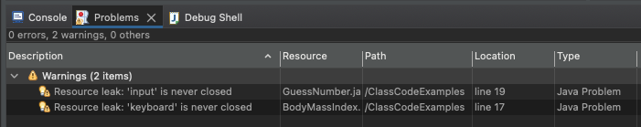

* Stop the Debugger process
  + If you still see the **red box** in the console window, it means the code is still running.
  + When the code is running there is a process in the task manager that is running.
  + Be sure to terminate the code before running it again otherwise you will be starting a new process on top of the process that is currently running.

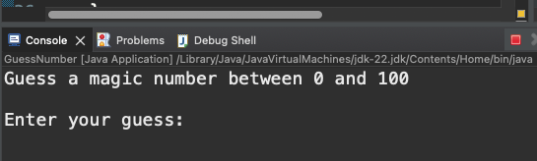

* To leave the debugger perspective **Window -> Open Perspective -> Java**

